PHASE 7 – Testing and Validation
Perform end-to-end validation to ensure that the Employee Raise Issue application, Record Producer, UI Policies, dependencies, and Service Portal work together correctly.

Test URL
Open the configured Service Portal using the project portal URL, for example: /employee_request.

End-to-End Test Cases
1. Open the Employee Request portal.
2. Verify that the portal logo/image and configured widgets are displayed.
3. Scroll to the custom widgets.
4. Hover over the widgets and verify the intended visual/animation behavior.
5. Click Raise Ticket.
6. Confirm that the Raise Employee Issue Record Producer opens.
7. Enter Requester, Category, Subcategory, State, and Short description.
8. Verify Category → Subcategory dependency.
9. Set State to New and verify that Short description becomes mandatory.
10. Verify that Number is read-only.
11. Submit the request.
12. Open the created Employee Raise Issue record and verify that the submitted values are stored correctly.

Validation Checklist
Application created and scoped correctly
Custom table and fields available
Choice values configured correctly
Reference fields point to correct tables
UI Policies behave as expected
Category/Subcategory dependency works
Record Producer creates records in the correct table
Portal displays both custom widgets
Raise Ticket redirects to the Record Producer
Submitted data is stored correctly
Portal home page
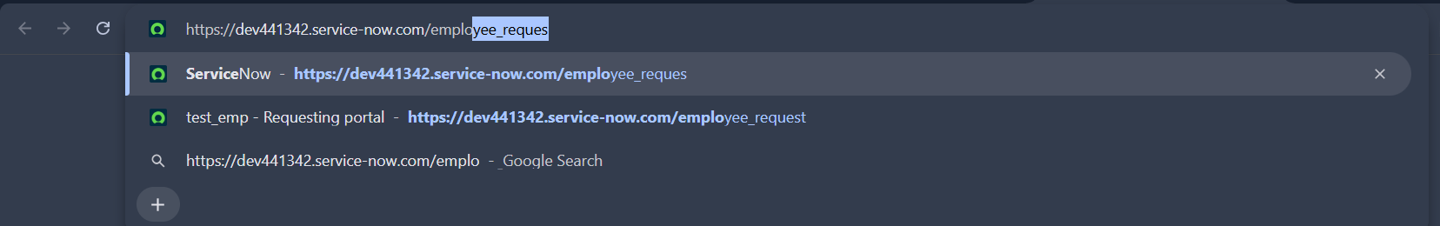
Widgets visible
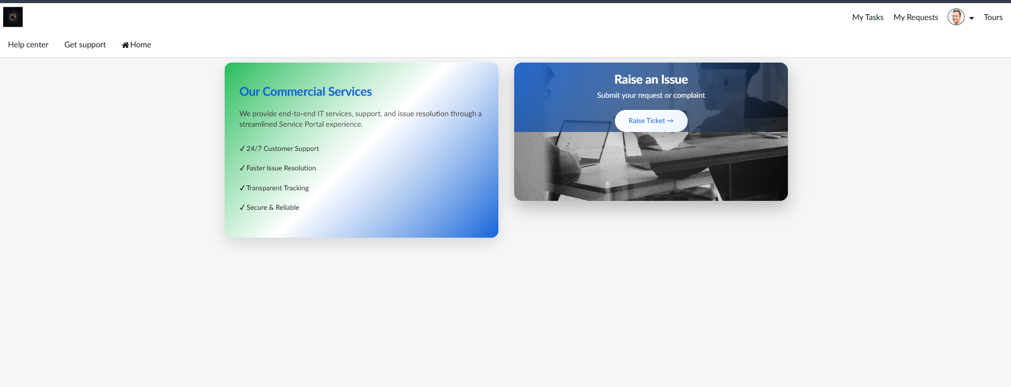
Record Producer form
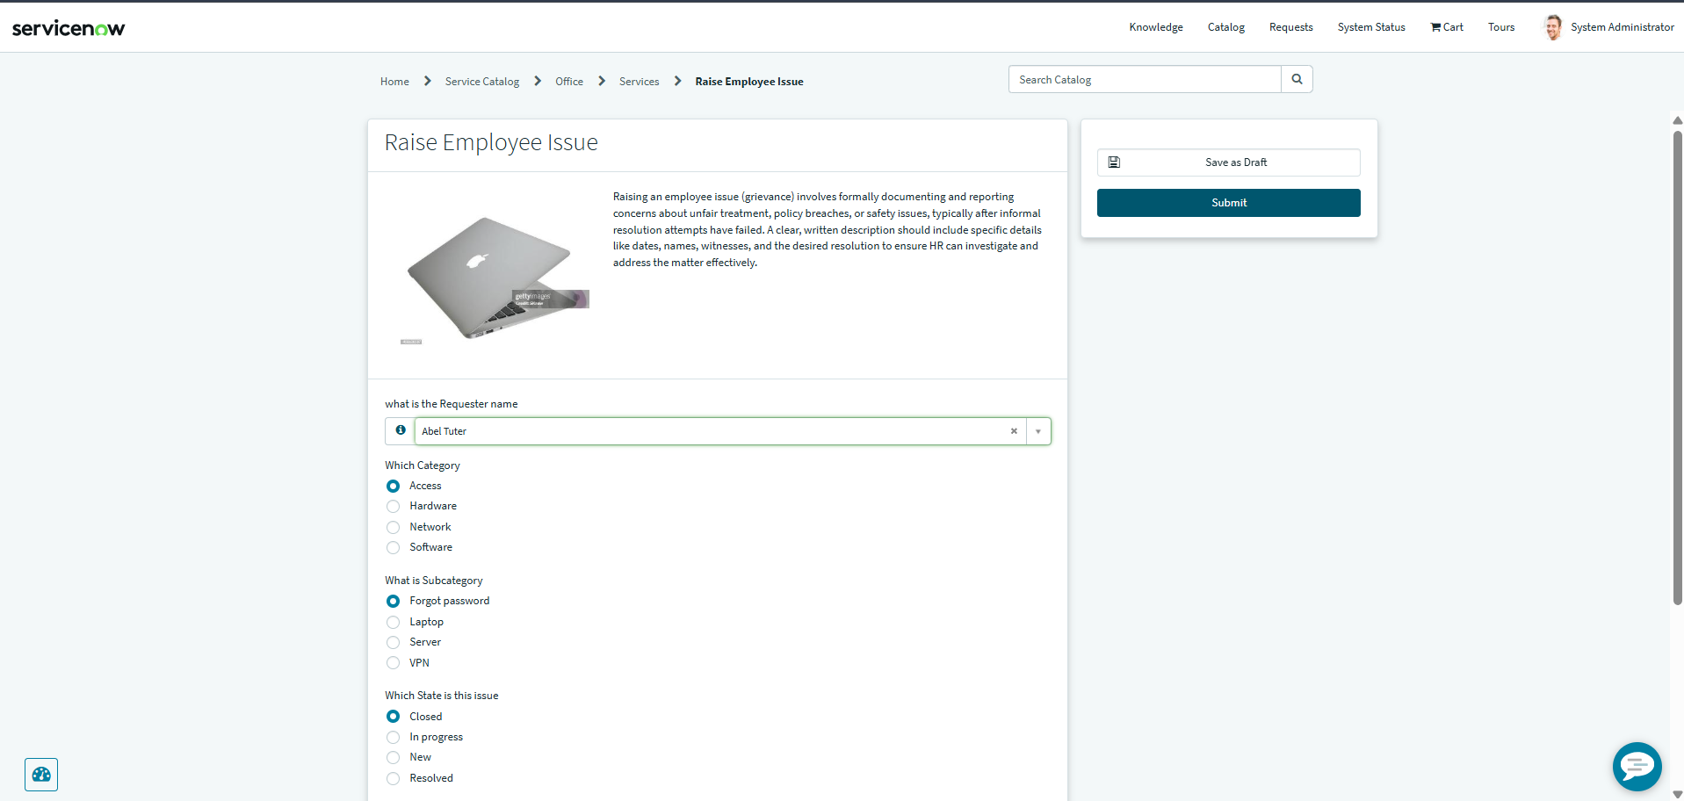
Mandatory field behavior
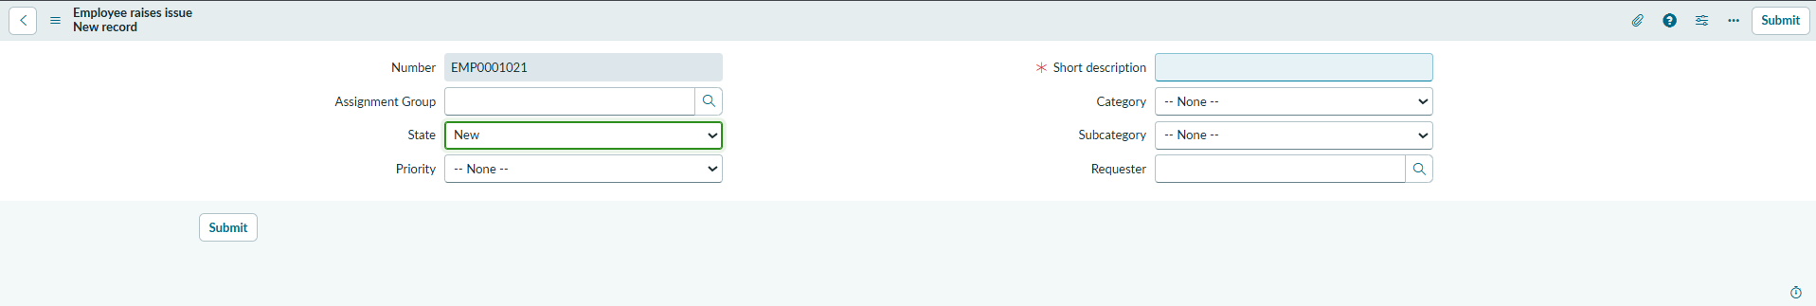
Dependent Subcategory choices
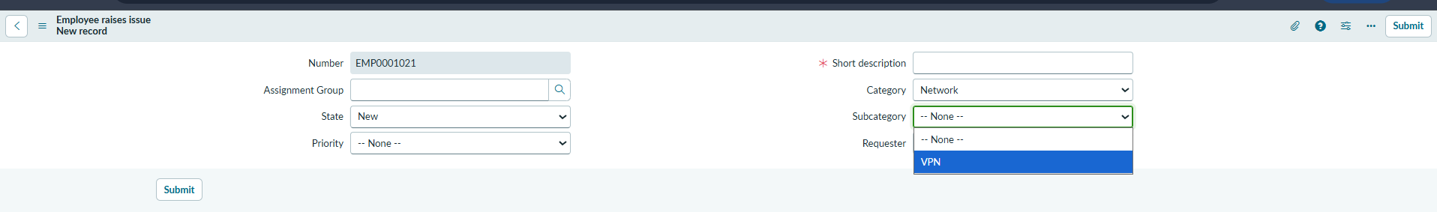
Created Employee Raise Issue record
